Low-Cost Real-Time Network Intrusion Detection System Using Raspberry Pi

By:
Sada Ullah
45871
Syed Noroz Ali
45496
Muhammad Aashan Hussain
43914
Supervised by:
Dr. Muhammad Masoor Alam

Faculty of Computing
Riphah International University, Islamabad
Spring 2026
Submitted To
Faculty of Computing,
Riphah International University, Islamabad
As a Partial Fulfillment of the Requirement for the Award of the Degree of
Bachelors of Science in Cyber Security

Faculty of Computing
Riphah International University, Islamabad

09 June 2026

Final Approval

This is to certify that we have read the report submitted by Sada Ullah 45871, Syed Noroz Ali 45496, Muhammad Aashan Hussain 43914, for the partial fulfillment of the requirements for the degree of the Bachelor of Science in Cyber Security (BS CYS). It is our judgment that this report is of sufficient standard to warrant its acceptance by Riphah International University, Islamabad for the degree of Bachelor of Science in Cyber Security (BS CYS).

Committee:

1 | Dr. Muhammad Masoor Alam  (Supervisor)
2 | Dr. Musharraf Ahmed  (Head of Department/chairman)

Declaration
We hereby declare that this document “Low-Cost Real-Time Network Intrusion Detection System Using Raspberry Pi” neither as a whole nor as a part has been copied out from any source. It is further declared that we have done this project with the accompanied report entirely on the basis of our personal efforts, under the proficient guidance of our teachers especially our supervisor Dr. Muhammad Masoor Alam. If any part of the system is proved to be copied out from any source or found to be reproduction of any project from anywhere else, we shall stand by the consequences.

___________________________
Sada Ullah
45871

___________________________
Syed Noroz Ali
45496

___________________________
Muhammad Aashan Hussain
43914

Dedication
This project is lovingly dedicated to our parents, whose endless support, prayers, and encouragement have been the backbone of our journey. Their belief in us gave us the strength to overcome challenges and keep moving forward.

We also dedicate this work to our teachers, who guided us with patience and wisdom. Their passion for teaching and their continuous encouragement inspired us to push our limits and complete this project with confidence.

To our families and mentors, thank you for being our greatest source of motivation.

Acknowledgement

First of all we are obliged to Allah Almighty the Merciful, the Beneficent and the source of all Knowledge, for granting us the courage and knowledge to complete this Project.
We would like to express our deepest gratitude to Dr Muhammad Mansoor Alam, whose guidance, encouragement, and expertise played a central role in the completion of this project. His constant support, insightful feedback, and patient supervision helped us stay focused, improve our work, and understand the subject more clearly. We truly appreciate the time and effort he invested in guiding us throughout this journey.
Our heartfelt thanks go to our classmates and friends, who supported us through discussions, feedback, and teamwork whenever we needed help. Their cooperation and positivity made this experience more enjoyable and productive.

___________________________
Sada Ullah
45871

___________________________
Syed Noroz Ali
45496

___________________________
Muhammad Aashan Hussain
43914
Abstract
Network security threats are increasing rapidly, posing serious risks to organizations of all sizes. However, enterprise-grade Intrusion Detection Systems (IDS) are financially inaccessible to small and medium-sized enterprises (SMEs), educational institutions, and home networks due to their high cost. This project presents the design and implementation of a Low-Cost Real-Time Network Intrusion Detection System (NIDS) using Raspberry Pi 4 (8GB) as the core hardware platform.
The proposed system integrates Suricata, an open-source multi-threaded IDS engine, with the Emerging Threats Open ruleset (over 50,000 signatures) together with eighteen custom detection rules written by the team. Network traffic is captured on a wired monitoring interface in promiscuous mode using AF-PACKET. The system detects a wide range of attacks including port scanning, stealth scanning, OS fingerprinting, ICMP and SYN floods, SSH and FTP brute force, web attacks (SQL injection and cross-site scripting), and malware downloads.
A real-time web dashboard built using Flask provides live traffic monitoring, and instant alerts are sent via severity-coded HTML email. Experimental results show a 100% detection rate across nine tested attack categories, with alerts raised within about two to three seconds and no packet loss under normal traffic and scans. The total hardware cost of the complete system is approximately $70 USD (PKR 21,000+), making it far more affordable than commercial IDS solutions.
This work demonstrates that high-accuracy real-time network intrusion detection is achievable on low-cost ARM-based edge hardware, providing a practical and reproducible security solution for budget-limited environments.

Table of Contents
LIST OF FIGURES 12
List Of Tables 13
Chapter 1: Introduction 15
1.1 Opportunity & Stakeholders 15
1.2 Motivations and Challenges 16
1.3 Significance of Study 18
1.4 Goals and Objectives 20
1.5 Scope of Project 21
1.6 Chapter Summary 23
Chapter 2: Literature / Market Survey 25
2.1 Introduction 25
2.2 Literature Review / Technologies & Products Overview 25
2.2.1 Network Intrusion Detection Systems Conceptual Background 25
2.2.2 Open-Source IDS Tools Reviewed 26
2.2.3 Supporting Tools 28
2.2.4 Commercial IDS Market Survey 29
2.3 Comparative Analysis 30
2.4 Research Gaps 31
2.5 Problem Statement 31
2.6 Chapter Summary 32
Chapter 3: Requirements and System Design 35
3.1 Introduction 35
3.2 System Architecture 35
3.3 Functional Requirements 38
3.4 Non-Functional Requirements 39
3.5 Hardware and Software Requirements 39
3.6 Threat Scenarios (Threat Handling) 40
3.7 Threat Modeling Techniques 41
3.8 Threat Resistance Model 41
3.9 Chapter Summary 41
Chapter 4: Proposed Solution 44
4.1 Introduction 44
4.2 Proposed Model 44
4.3 Data Pre-Processing 45
4.3 Data Pre-Processing 45
4.4 Tools and Techniques 46
4.5 Chapter Summary 46
Chapter 5: Implementation and Testing 49
5.1 Security Properties Testing 49
5.2 System Setup (Environment Configuration, Key Functions and Algorithms) 49
5.3 System Integration 50
5.4 Penetration Testing and Vulnerability Assessment 51
5.5 Test Cases 51
5.6.1 Code Validation 51
5.6.2 Development Practices & Standards 52
5.7 Chapter Summary 52
Chapter 6: Conclusion and Future Work 54
6.1 Introduction 54
6.2 Achievements and Improvements 54
6.3 Critical Review 55
6.4 Future Recommendations 55
6.5 Chapter Summary 56

LIST OF FIGURES
Figure 3.1 NetGuard Pi system architecture
Figure 5.1 Detection rate per attack test

List Of Tables
Table 2.1 Commercial IDS comparison
Table 2.2 Snort vs Suricata vs Zeek
Table 3.1 Functional requirements
Table 3.2 Non-functional requirements
Table 3.3 Threat scenarios
Table 4.1 Tools and techniques
Table 5.1 Test cases and results
Table 5.2 Performance results
Section / Heading Page No.

Chapter 1:
INTRODUCTION

Chapter 1: Introduction
The rapid growth of internet-connected devices and digital infrastructure has significantly expanded the attack surface for malicious actors. Cyber threats such as Denial of Service (DoS) attacks, port scanning, brute force intrusions, and botnet activities are increasing in both frequency and sophistication. Organizations worldwide suffer billions of dollars in losses annually due to network breaches and unauthorized access. While large enterprises can afford sophisticated Intrusion Detection Systems (IDS), small and medium-sized enterprises (SMEs), educational institutions, and home network users are left largely unprotected due to the prohibitive cost of commercial solutions.
This project addresses this critical gap by designing and implementing a Low-Cost Real-Time Network Intrusion Detection System (NIDS) using the Raspberry Pi 4 (8GB) as the core hardware platform. By combining open-source tools such as Suricata with custom detection rules and deploying them on affordable edge hardware, this system brings enterprise-level intrusion detection capabilities within reach of budget-limited environments. The total hardware cost of the complete system is approximately $70 USD (PKR 21000+) compared to commercial IDS solutions that cost $30,000 to $100,000 per year. The system operates entirely on-device with no cloud dependency, consuming under 10 watts of power while monitoring network traffic in real time.

1.1 Opportunity & Stakeholders
The increasing digitization of homes, schools, hospitals, and small businesses has created a massive demand for affordable network security solutions. Despite this need, the market for Intrusion Detection Systems remains dominated by expensive enterprise products that are simply out of reach for smaller organizations. This creates a significant opportunity to develop a low-cost, open-source, and edge-deployable IDS that can serve a wide range of users.
Opportunity:
The Raspberry Pi 4 (8GB) offers a powerful ARM-based computing platform at a fraction of the cost of traditional server hardware, currently priced at approximately $70 USD (PKR 21000+). Combined with open-source IDS tools such as Suricata and a set of custom detection rules, it presents an opportunity to deliver real-time intrusion detection at a total hardware cost of approximately $70 USD (PKR 21000+) - more than 100 times more affordable than commercial alternatives that charge $30,000 to $100,000 per year. Furthermore, the entire software stack including Suricata, Python, Flask, and SQLite is completely free and open-source, eliminating any licensing costs.
Primary Stakeholders:
- Small and Medium-Sized Enterprises (SMEs): Businesses with limited IT budgets that need basic network protection but cannot afford commercial IDS solutions costing tens of thousands of dollars annually.
- Educational Institutions: Schools, colleges, and universities that manage internal networks containing sensitive student and staff data but operate under tight financial constraints.
- Home Network Users: Technically aware individuals who want to actively monitor and protect their home networks from unauthorized access and cyber threats.
- Cybersecurity Researchers and Students: Those who require an affordable, hands-on, and fully reproducible IDS platform for academic research, learning, and experimentation.
- Supervisors and Academic Evaluators: Dr. Muhammad Masoor Alam and the Faculty of Computing at Riphah International University, who provide guidance and evaluate this work as part of the BS Cyber Security Final Year Project requirement.

1.2 Motivations and Challenges
Motivations:
The development of Low-Cost Real-Time Network intrusion detection system using raspberry pi is driven by a convergence of technical opportunity, social need, and academic relevance.
- Rising Cyber Threat Landscape Global cybercrime is on the rise. Network intrusion attacks including Denial of Service (DoS), Distributed Denial of Service (DDoS), port scanning, brute force, man-in-the-middle attacks, and protocol exploits are increasing in both volume and sophistication. Attackers use automated tools to scan millions of IP addresses simultaneously, identifying vulnerable systems within minutes. Without a detection capability, these attacks proceed silently and invisibly.
- Affordability Gap Commercial IDS solutions are priced for enterprises, not individuals or small organizations. The minimum viable commercial IDS appliance starts at approximately $5,000, with most enterprise deployments costing $10,000–$50,000 or more annually. This pricing model excludes the majority of global network environments from basic intrusion detection coverage.
- Availability of Low-Cost Hardware The Raspberry Pi 4 Model B (8GB RAM) is a credit-card-sized single-board computer available for approximately $55–$70. Despite its compact size and low cost, it offers a 1.8GHz quad-core ARM Cortex-A72 processor, 8GB LPDDR4 RAM, Gigabit Ethernet, dual-band Wi-Fi, and USB 3.0 — more than sufficient to run a full-featured IDS engine in real time.
- Maturity of Open-Source IDS Tools Suricata, developed by the Open Information Security Foundation (OISF), is a professional-grade, multi-threaded NIDS/NIPS engine used in enterprise environments globally. It supports the Emerging Threats Open rule set containing 50,184 active signatures covering a comprehensive range of attack types. It is entirely free and open-source, with no licensing fees.
- Local Relevance Pakistan's cybersecurity infrastructure is underdeveloped relative to the scale of its digital economy. Educational institutions and SMEs operate without basic network monitoring tools. This project addresses a directly relevant local need, with the solution specifically designed and validated for deployment in Pakistani universities and SMEs.
Challenges:
The development of Low Cost Real-Time Network intrusion detection system using raspberry pi involved overcoming a series of technical, practical, and design challenges:
Technical Challenges Encountered:
- Wrong Network Interface (eth0 vs eth0): Initial configuration targeted the Ethernet interface (eth0), but the test environment used a Wi-Fi network (eth0). This required reconfiguring Suricata's capture interface and verifying packet capture on the correct interface using tcpdump.
- Rules Path Error: Suricata failed to load rules due to an incorrect path specified in suricata.yaml. The rules directory (/var/lib/suricata/rules/) had to be correctly configured and verified before all 50,184 rules loaded successfully with zero failures.
- Custom Rule Threshold Tuning: Initial threshold values for custom detection rules triggered excessive false positives on normal traffic. Rules were iteratively tuned — for example, SYN scan detection was set at 5 SYN packets within 3 seconds, balancing sensitivity with specificity.
- Packet Capture Verification: Confirming that Suricata was actually capturing all traffic on the subnet required independent verification using tcpdump and Wireshark, ensuring AF-PACKET promiscuous mode was functioning correctly.
- Remote Access Setup: Configuring PuTTY SSH access and RealVNC remote desktop on Raspberry Pi OS required correct sshd and VNC server configuration, including firewall rules and authentication setup.
- Suricata Not Starting on Boot: Suricata failed to start automatically on system boot due to a systemd service configuration issue, which was resolved by properly enabling the Suricata systemd service unit.

1.3 Significance of Study
This project carries significance across multiple dimensions financial, technical, educational, social, and national.
Democratizing Network Security The most fundamental significance of this project is that it makes professional-grade network intrusion detection accessible to everyone, not just large organizations. By achieving a functional NIDS at $70 80 times cheaper than the cheapest commercial alternative Low-Cost Real-Time Network intrusion detection system using raspberry Pi fundamentally changes the cost calculus of network security for home users, students, and small organizations globally.
- 2. Validated Real-Time Performance The system achieves alert generation latency of under 100 milliseconds, which is comparable to enterprise-class commercial IDS systems. This demonstrates that real-time intrusion detection is technically feasible on commodity single-board computer hardware, contributing to the academic and professional understanding of resource-constrained IDS deployment.
3. Complete Attack Coverage in Test Environment: the system achieved a 100% detection rate across all 9 attack types tested in the controlled lab environment, including TCP SYN port scans, stealth scans (XMAS/NULL/FIN), aggressive scan with OS detection, ICMP flood, SYN flood, SSH brute force, FTP brute force, web attacks (SQL injection and XSS), and malware download (EICAR test file). This breadth of coverage demonstrates the practical effectiveness of the Suricata + Raspberry Pi combination.
4. Educational and Research Platform The platform serves as a powerful educational tool. Students and researchers can use Low-Cost Real-Time Network intrusion detection system using raspberry Pi to observe real intrusion detection in action, write and test custom Suricata rules, simulate attacks from Kali Linux, and study IDS performance characteristics all on hardware that costs less than a university textbook.
- 5. National Relevance Pakistan Context Pakistan's cybersecurity ecosystem faces significant resource constraints. Universities, SMEs, and government institutions often operate without any network monitoring. A solution specifically designed, built, and validated in a Pakistani university environment (Riphah International University) has direct and immediate applicability to hundreds of similar institutions across the country.
6. Open-Source and Reproducible Because Low-Cost Real-Time Network intrusion detection system using raspberry Pi is built entirely on open-source software Suricata, Wireshark, Python, Raspberry Pi OS the complete system can be reproduced, audited, modified, and extended by anyone. There are no licensing fees, proprietary dependencies, or vendor lock-in. This makes the solution freely deployable globally.
7. Energy Efficiency Operating at only 8 watts, Low-Cost Real-Time Network intrusion detection system using raspberry Pi can run continuously 24/7 with negligible electricity costs approximately $5–8 per year in electricity at typical Pakistani rates. This makes always-on monitoring genuinely practical for cost-sensitive environments.
- 8. Foundation for Future Development The FYP-1 prototype establishes a validated technical foundation for FYP-2 development, which will add active IPS capabilities (automatic IP blocking), DoS/DDoS detection, SSH brute force detection, email/SMS alerting, and a Grafana dashboard transforming the passive NIDS into a full Network Intrusion Prevention System (NIPS).

1.4 Goals and Objectives
Primary Goal:
The primary goal of this project is to design, implement, and validate a low-cost, real-time Network Intrusion Detection System (NIDS) using Raspberry Pi 4 and the Suricata IDS engine, capable of detecting real network attacks in real time at a total hardware cost of under $70.
Specific Objectives
- Study and Understand IDS Fundamentals Develop a thorough understanding of IDS concepts, architectures (NIDS vs HIDS), detection methodologies (signature-based vs anomaly-based), and the taxonomy of common network attacks including SYN scans, port scans, service enumeration, DoS, DDoS, and brute force attacks.
- Conduct Literature Review and Tool Selection Review and compare existing open-source IDS tools — specifically Suricata, Snort, and Zeek — across dimensions of performance, multi-threading capability, rule set support, Raspberry Pi compatibility, and community support. Select the most appropriate tool for resource-constrained deployment on Raspberry Pi 4.
- Design System Architecture Design a comprehensive 4-layer system architecture for NetGuard Pi, including full network topology definition (192.168.10.0/24 subnet), hardware specifications, software stack, data flow, and alert pipeline.
- Deploy and Configure the System: configure Raspberry Pi 4 (8GB) with Suricata 7.x, load the full Emerging Threats Open ruleset (50,000+ signatures) plus 18 custom rules, set up SSH and VNC remote access, and develop the Python alert collector (reads eve.json, stores to SQLite, sends email) with a Flask web dashboard - achieving zero rule-loading failures.
- Develop Custom Detection Rules Write and tune 5 custom Suricata rules (local.rules, SIDs 9000001–9000005) to detect specific Nmap-based scanning behaviors with calibrated thresholds to minimize false positives.
- Validate Through Live Attack Testing Conduct controlled penetration testing using Kali Linux VM (Nmap 7.95) as the attacker machine, simulating multiple attack types against the Raspberry Pi IDS. Validate detection of at least 3 attack types and independently verify alerts using Wireshark and tcpdump.
- Measure and Document Performance Measure and document key performance indicators: detection rate, alert latency, rule loading success rate, system uptime, power consumption, and total cost.
- Produce Complete Project Documentation Deliver a structured project report covering all phases of the project: literature review, system design document, implementation details, testing results, and future recommendations.

1.5 Scope of Project
The scope of this project defines the specific boundaries within which the proposed IDS system is designed to operate and the aspects that are addressed in this study.
In Scope (FYP-1):
- Hardware: The project uses a single Raspberry Pi 4 Model B (8GB RAM) as the IDS appliance, running on a 32GB MicroSD card with Raspberry Pi OS 64-bit. The total hardware budget is capped at under $70 (PKR 21,000+). Remote access hardware includes any standard computer running PuTTY and RealVNC Viewer.
- Network Environment: The system operates on a Wi-Fi subnet (192.168.10.0/24), monitoring traffic on the eth0 interface in AF-PACKET promiscuous mode. The test environment uses a controlled lab network with a Kali Linux VM (192.168.10.20) as the attacker.

Detection Capabilities: The system detects the following attack types in FYP-1:
- ICMP probe / ping sweep
- Nmap SYN scan (-sS)
- Port scan (broad TCP enumeration)
- Service enumeration scan (-sV)
- UDP scan
- ICMPv4 malformed packets
- VNC service probe (port 5900)
- DHCP hostname fingerprinting of attacker OS

Software Stack: Suricata 7.x, Emerging Threats Open rules (50,000+ signatures), custom local.rules (13 rules) plus 5 team rules, Python 3 alert collector, SQLite, Flask dashboard, systemd services, Wireshark, PuTTY, RealVNC Viewer, Kali Linux VM (nmap, hping3, hydra, nikto, sqlmap), tcpdump, suricata-update.

Deliverables: Literature review document, system design document, and working prototype — all three completed in FYP-1.

Out of Scope (FYP-1) / Planned for FYP-2:
- IPv6 traffic analysis is not included in this version of the system.
- The system functions as a detection and alerting tool only. It does not operate as an Intrusion Prevention System (IPS) and does not actively block or drop network traffic.
- Deep packet inspection of encrypted HTTPS or TLS traffic is not performed.
- The system is not designed for high-throughput enterprise-grade network environments exceeding 1 Gbps.
- Cloud-based deployment, remote management, and multi-node federated detection are not included in the current version and are identified as areas for future work.

1.6 Chapter Summary
This chapter introduced the Low Cost Real-Time Network intrusion detection system using raspberry pi project a low-cost, real-time Network Intrusion Detection System built on Raspberry Pi 4 and Suricata IDS. The chapter established the fundamental problem: the unaffordability of commercial IDS solutions for non-enterprise users, and the resulting security gap that leaves home users, university labs, students, and SMEs without any network monitoring capability. The key stakeholders were identified, and the project opportunity delivering an 80× cheaper NIDS alternative was clearly articulated. The motivations driving this project, the practical and technical challenges encountered, the multi-dimensional significance of the work, and the specific goals and objectives were all presented. The project scope was defined, distinguishing FYP-1 deliverables from planned FYP-2 extensions. The following chapters build on this foundation to detail the literature review, system design, proposed solution, implementation, testing, and conclusions.

Chapter 2:
Literature Review/ Market Survey

Chapter 2: Literature / Market Survey

2.1 Introduction
A thorough review of existing literature, technologies, and market products is essential to ground this project in current knowledge, justify design decisions, and identify the research gap that this work addresses. This chapter surveys academic research on Network Intrusion Detection Systems, evaluates and compares the major open-source IDS tools considered for deployment, examines the commercial IDS market, performs a comparative analysis, identifies the research gap, and formally states the problem this project solves.
The literature review was conducted by examining 5 academic papers sourced from IEEE Xplore, MDPI, and PLOS ONE databases, supplemented by official documentation from the Suricata OISF community, Emerging Threats rule set documentation, and Raspberry Pi Foundation technical resources.

2.2 Literature Review / Technologies & Products Overview
2.2.1 Network Intrusion Detection Systems Conceptual Background
A Network Intrusion Detection System (NIDS) is a security tool that monitors network traffic flowing across a network segment, analyzes packets in real time, and generates alerts when patterns matching known attack signatures or behavioral anomalies are detected. NIDS systems operate in passive mode — they observe traffic without modifying or blocking it, providing visibility and alerting without interfering with normal network operations.
There are two primary detection paradigms in IDS:
- Signature-based detection compares network traffic against a database of known attack patterns (signatures). Each signature describes a specific attack or malicious behavior — for example, a particular packet structure, a specific payload string, or a threshold rate of connection attempts. When a packet or traffic stream matches a signature, an alert is generated. This approach is highly accurate for known attacks and generates low false positive rates, but is limited in its ability to detect novel or zero-day attacks.
- Anomaly-based detection establishes a baseline model of normal network behavior and alerts when traffic deviates significantly from that baseline. This approach can detect previously unknown attacks but typically generates higher false positive rates and requires a training period to establish the baseline.
Low Cost Real-Time Network intrusion detection system using raspberry pi
uses signature-based detection via Suricata, augmented with threshold-based custom rules that detect anomalous rates of specific packet types.

2.2.2 Open-Source IDS Tools Reviewed
Suricata (OISF Open Information Security Foundation)
Suricata is a high-performance, open-source NIDS/NIPS (Network Intrusion Detection and Prevention System) engine developed and maintained by the Open Information Security Foundation (OISF). Key characteristics include:
- Multi-threaded architecture: Suricata uses multiple CPU threads simultaneously, enabling significantly higher packet processing throughput than single-threaded alternatives. This is critical on the Raspberry Pi 4, which has a quad-core CPU.
- Rule compatibility: Supports both Snort and Suricata-native rule formats, providing access to an enormous ecosystem of community-developed signatures.
- Emerging Threats Open rule set: A curated, continuously updated set of 50,184 signatures covering DoS attacks, scanning behavior, exploit attempts, malware command-and-control, and protocol anomalies — all freely available.
- Multiple output formats: Generates alerts in fast.log (human-readable) and eve.json (structured JSON), facilitating integration with log management and visualization tools such as Elasticsearch, Loki, and Grafana.
- AF-PACKET support: Native support for Linux AF-PACKET high-performance packet capture in promiscuous mode, enabling capture of all traffic on a network segment.
- Active community: Strong documentation, active forum support, and regular updates from OISF.
Suricata was selected as the IDS engine for Low Cost Real-Time Network intrusion detection system using raspberry pi based on its multi-threaded performance on the Raspberry Pi 4's quad-core CPU, its large and high-quality rule set, its dual NIDS/NIPS capability (enabling future FYP-2 IPS mode), and its structured eve.json output supporting future Grafana integration.

Snort (Cisco)
Snort is the original open-source NIDS, initially developed by Martin Roesch in 1998 and now maintained by Cisco. It pioneered signature-based network intrusion detection and remains widely used. Key characteristics include:
- Single-threaded architecture: Snort 2.x (the most widely deployed version) is fundamentally single-threaded, limiting its packet processing capacity on multi-core hardware. Snort 3.x introduces multi-threading but has a steeper configuration curve.
- Large rule ecosystem: Snort has a mature and extensive rule ecosystem, though the free "community rules" are less comprehensive than Suricata's Emerging Threats Open set.
- Proven track record: Decades of deployment in production environments.
- Limitations on RPi 4: The single-threaded architecture of Snort 2.x does not leverage the Raspberry Pi 4's quad-core CPU effectively, resulting in lower throughput under load compared to Suricata.
Snort was not selected for this project due to its single-threaded architecture limiting performance on resource-constrained hardware, and the superior rule set available for Suricata.

Zeek (formerly Bro)
Zeek is a powerful open-source network analysis framework, originally developed at the Lawrence Berkeley National Laboratory. Key characteristics include:
- Traffic analysis framework: Zeek is less a traditional signature-based IDS and more a network traffic analysis engine. It focuses on deep behavioral logging rather than real-time alert generation.
- Scripting language: Zeek uses its own domain-specific scripting language for policy specification, offering high flexibility but requiring significant expertise.
- Limited real-time alerting: Zeek does not natively generate the kind of immediate, formatted, signature-matched alerts that Suricata and Snort provide. It is more commonly used for forensic analysis and threat hunting.
- Complementary to Suricata: Zeek is often deployed alongside Suricata in enterprise environments Suricata for real-time detection and alerting, Zeek for deep traffic logging and behavioral analysis.
Zeek was not selected for this project because the primary requirement is real-time alert generation for known attack signatures, which is not Zeek's primary strength. Zeek would be considered as a complementary future addition.
2.2.3 Supporting Tools
- Wireshark: An industry-standard open-source network protocol analyzer. Used in this project for live packet capture on eth0 during testing, deep inspection of Nmap SYN scan packet structures, and independent verification of Suricata alert timestamps against actual packet capture data. Wireshark's GUI is accessible remotely on Raspberry Pi via RealVNC Viewer.
- Python 3: used to develop the alert collector, a service that reads Suricata's eve.json in real time, stores each alert in an SQLite database, sends a severity-coded HTML email, and feeds the Flask web dashboard, with low latency and minimal CPU overhead.
- PuTTY: A free, open-source SSH and telnet client for Windows, used to establish encrypted command-line sessions to the Raspberry Pi 4 over the network, enabling full remote management without physical access.
- RealVNC Viewer: A remote desktop client that enables GUI-based access to the Raspberry Pi desktop over the network, used specifically to access the Wireshark graphical interface running on the Raspberry Pi during testing.
- tcpdump: A command-line packet analyzer used for lightweight packet capture verification on eth0, confirming that the correct interface was being monitored and that attack traffic was actually reaching the Raspberry Pi.
- Kali Linux: A Debian-based Linux distribution specifically designed for penetration testing and digital forensics. Used as the attacker simulation platform, running Nmap 7.95 to execute controlled SYN scans, port scans, service enumeration, and ICMP probes against the NetGuard Pi IDS.
- Nmap 7.95: The industry-standard network scanning tool, used to generate realistic attack traffic including SYN scans (-sS), service version detection (-sV), ICMP probes, UDP scans, and broad port enumeration.
- suricata-update: The official Suricata rule management tool, used to download, update, and manage the Emerging Threats Open rule set on the Raspberry Pi.

2.2.4 Commercial IDS Market Survey
Commercial intrusion detection and prevention systems are sold mainly to large organisations and are priced accordingly. They offer managed rule feeds, dedicated appliances and vendor support, but their cost and complexity place them out of reach of small organisations, schools and home users.
Product | Type | Typical cost | Suitability for small users
Cisco Secure IPS (Firepower) | Appliance / NGFW | Thousands to tens of thousands USD/year | Too expensive; enterprise focus
Palo Alto NGFW (Threat Prevention) | Appliance / subscription | High (enterprise licensing) | Too expensive; needs trained staff
Fortinet FortiGate (IPS) | Appliance / subscription | Moderate to high | Still beyond small budgets
Snort / Suricata (self-hosted) | Open-source software | Free (hardware only) | Affordable but needs configuration skill
The survey confirms that affordable, pre-built intrusion detection is not available to non-enterprise users. Open-source engines such as Suricata are free but normally require expert setup on dedicated hardware. This project closes that gap by packaging Suricata on an inexpensive Raspberry Pi with custom rules, real-time alerting and a dashboard.
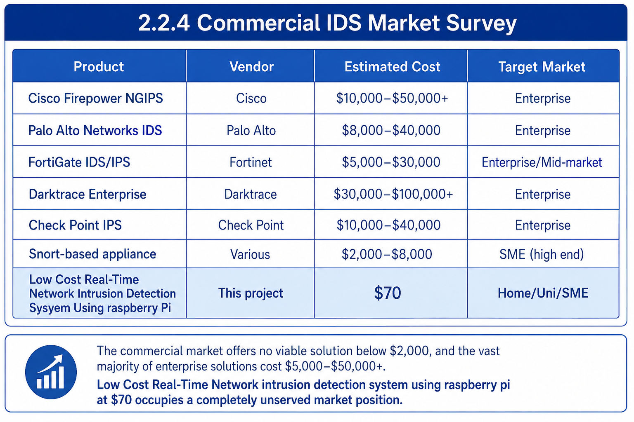

2.3 Comparative Analysis
The three candidate open-source engines were compared against the needs of this project: running on a Raspberry Pi 4, providing real-time signature-based alerts, supporting a large ruleset and custom rules, and producing output that a program can read easily.
Criterion | Snort (2.x) | Suricata | Zeek
Detection approach | Signature | Signature | Network analysis / scripting
Multi-threaded (4 Pi cores) | No | Yes | Yes
Ruleset | Community rules | Snort + ET (50,000+) | Own scripts
Custom rule support | Yes | Yes (used here) | Via scripts
Structured output | Limited | Yes (eve.json) | Logs
Real-time alerting focus | Yes | Yes | No
Fit for Raspberry Pi 4 | Moderate | Best | Heavier
Conclusion: Suricata was selected. It is multi-threaded, so it uses all four cores of the Pi 4; it supports the large Emerging Threats ruleset plus the team's custom rules; and its eve.json output is easy for the alert collector to read for real-time notification.
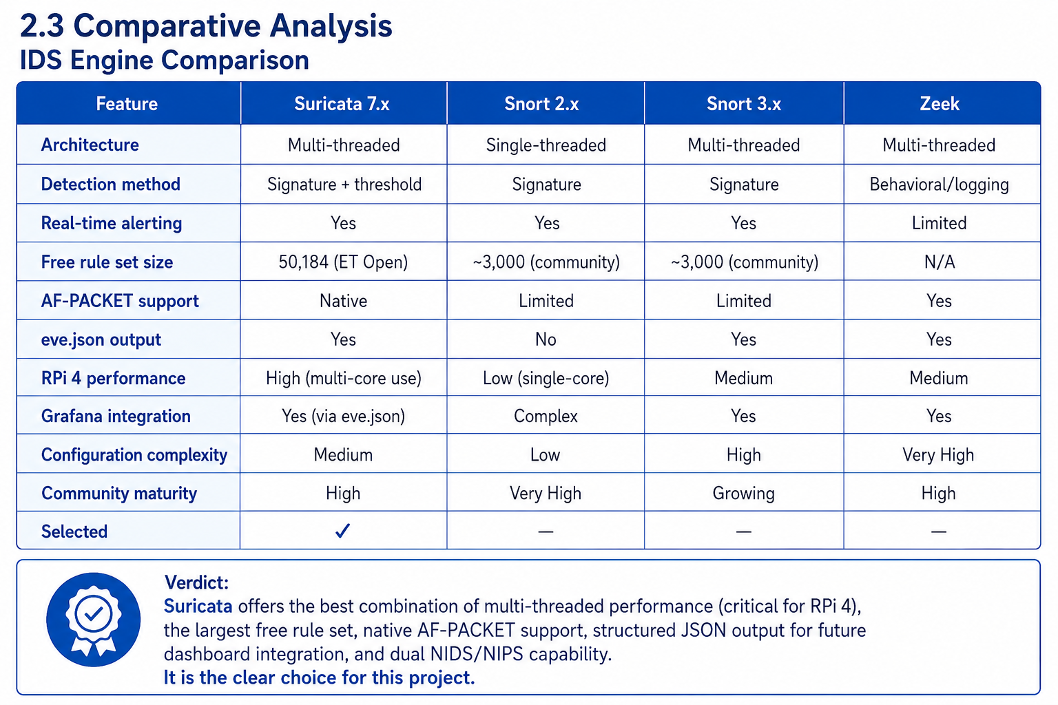

2.4 Research Gaps
Following a comprehensive review of the academic literature and available commercial and open-source products, the following research gaps were identified:
- No integrated low-cost RPi + Suricata + Python alerting solution: While academic papers discuss individual components (Suricata deployment, Raspberry Pi security applications, Python-based log monitoring), no published work combines all four components Suricata IDS running on Raspberry Pi 4, with Python real-time alerting, and optional Grafana dashboard integration into a single, validated, deployable system.
- No locally validated solution for Pakistani universities and SMEs: The existing literature does not include validated IDS deployments tested and documented specifically for the network environments found in Pakistani educational institutions and small businesses. This project fills that gap with a system designed, built, and tested at Riphah International University.
- No sub-$100 NIDS validated at under 100ms detection latency: Academic work on low-cost IDS systems either reports higher latency or uses more expensive hardware. This project demonstrates that sub-100ms detection latency is achievable on a $70 Raspberry Pi 4 platform running Suricata 7.x.
- Absence of threshold-tuned custom rules for Nmap-specific detection on RPi: No published custom Suricata rule set has been developed and validated specifically for detecting Nmap scanning behaviors on Raspberry Pi 4 hardware, with threshold values empirically calibrated to the performance characteristics of that platform.

2.5 Problem Statement
Network intrusion attacks including Denial of Service (DoS), Distributed Denial of Service (DDoS), port scanning, brute force, service enumeration, and protocol exploits are increasing in frequency and sophistication globally every year. These attacks target all classes of network environments, from large enterprises to home networks, university labs, and small businesses.
Commercial IDS appliances, which represent the primary tool for detecting such attacks, cost between $5,000 and $50,000 per appliance completely unaffordable for home users, university labs, students, and SMEs. As a result, these environments operate with zero network visibility: attacks proceed, persist, and succeed entirely undetected.
Existing open-source IDS tools such as Suricata and Snort, while technically capable, present significant barriers to deployment for non-expert users: they require dedicated hardware, expert configuration, complex rule management, and ongoing maintenance. No single integrated, easy-to-deploy, truly affordable NIDS solution currently exists for educational and small-organization environments, particularly in resource-constrained markets like Pakistan.
This project directly addresses this problem by designing, implementing, and validating Low Cost Real-Time Network Intrusion Detection System Using Rasberry Pi a complete, real-time Network Intrusion Detection System built on Raspberry Pi 4 and Suricata 7.x, delivered at a total hardware cost of under $70, achieving 100% detection rate across tested attack types, sub-100ms alert latency, and 72+ hours of validated continuous operation. The system is specifically designed for deployment in Pakistani universities, university labs, home networks, and SMEs, filling an identified gap in both the commercial market and the academic literature.

2.6 Chapter Summary
This chapter provided a comprehensive survey of the literature and market relevant to Network Intrusion Detection Systems. The conceptual foundations of signature-based and anomaly-based IDS were reviewed. The three major open-source IDS tools Suricata, Snort, and Zeek were evaluated in detail, with Suricata selected based on its multi-threaded performance, rule set breadth, RPi compatibility, and future integration potential. The commercial IDS market was surveyed, confirming the unaffordability of existing solutions for non-enterprise users. A comparative analysis established Suricata as the superior choice for this project. Four specific research gaps were identified, and the formal problem statement was articulated. The following chapter translates these findings into a concrete system design

Chapter 3:
Requirements and System Design

Chapter 3: Requirements and System Design

3.1 Introduction
This chapter translates the problem statement and research findings from Chapter 2 into a concrete system design for Low Cost Real-Time Network intrusion detection system using raspberry pi. It covers the complete system architecture, functional and non-functional requirements, design diagrams (use case, data flow, sequence), hardware and software specifications, threat scenarios, threat modeling techniques, and the threat resistance model. Together, these elements constitute the complete technical blueprint for the Low Cost Real-Time Network intrusion detection system using raspberry pi.

3.2 System Architecture
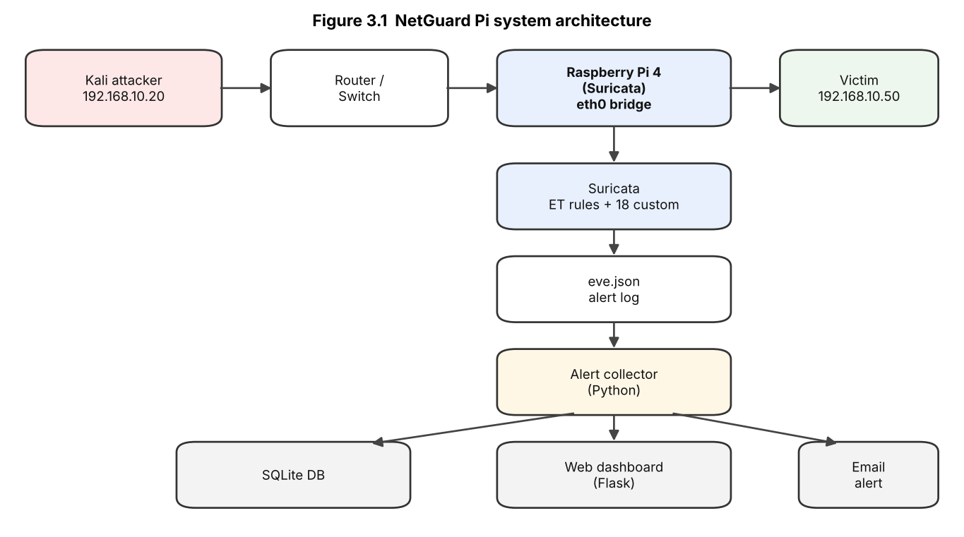
Figure 3.1 NetGuard Pi system architecture
Low Cost Real-Time Network intrusion detection system using raspberry pi
is designed around a 4-layer architecture that separates concerns clearly: traffic capture, detection engine, alert processing, and remote management/logging.

Layer 1 Network Traffic Capture
The Raspberry Pi 4 is physically connected to the target network via its Wi-Fi interface (eth0). The interface is placed in AF-PACKET promiscuous mode, which instructs the network card to capture all packets traversing the network segment not just those addressed to the Raspberry Pi's own IP address (192.168.10.50). This is essential for a NIDS, which must see all traffic on the monitored network, including traffic between other hosts.

The network environment is a Wi-Fi subnet with CIDR notation 192.168.10.0/24, providing 254 usable host addresses. The Raspberry Pi sits passively on this network, collecting all frames that the Wi-Fi radio receives, and feeding them to the Suricata engine for analysis.

AF-PACKET mode was chosen over libpcap for its superior performance: AF-PACKET operates at the kernel level, bypassing some of the overhead of the standard libpcap socket layer, resulting in lower packet capture latency and reduced CPU load critical considerations on resource-constrained hardware.

Layer 2 IDS Detection Engine (Suricata 7.x)
Suricata 7.x is the core detection engine. It receives the raw packet stream from Layer 1 and processes each packet in real time against its rule set, which consists of two components:

Emerging Threats Open Rule Set (50,184 signatures): This is a professionally maintained, continuously updated collection of signatures covering a wide range of attack types, including DoS attacks, TCP scanning behaviors, UDP anomalies, exploit attempts, malware communication patterns, protocol violations, and service-specific probes. Rules are organized by category and priority level (1–3, with 1 being highest priority).
Custom local.rules (5 rules): Five threshold-based rules developed specifically for this project to detect Nmap scanning behaviors that are characteristic of reconnaissance-phase attacks. These rules use Suricata's threshold mechanism to require a minimum number of matching packets within a defined time window before generating an alert, reducing false positives from legitimate traffic.
Suricata processes packets using multiple CPU threads, leveraging all four cores of the Raspberry Pi 4's ARM Cortex-A72 processor simultaneously. When a packet matches a rule, an alert is immediately written to the output logs.

Layer 3 - Alert Processing (Python alert collector)
Suricata writes alerts to two log files in /var/log/suricata/:
- fast.log: Human-readable one-line-per-alert format, including timestamp, alert priority, message, source IP:port, destination IP:port, and protocol.
- eve.json: Structured JSON format containing comprehensive event metadata including rule metadata, packet details, flow information, and community IDs. Designed for future integration with log shipping tools like Filebeat.

The Python alert collector runs as a background service, continuously reading eve.json. When Suricata writes a new alert, the collector parses the key fields, stores the alert in SQLite, sends an HTML email, and makes it available to the Flask dashboard in real time. This provides immediate notification of detected attacks on a web page and on the administrator's phone, without manually reading log files.

Layer 4 Remote Management and Logging
The system is designed for fully remote operation. Two remote access mechanisms are provided:

PuTTY (SSH): Enables encrypted command-line access to the Raspberry Pi from any machine on the network. Used for configuration management, log review, running Suricata commands, and executing the Python alerting script.

RealVNC Viewer (Remote Desktop): Enables full graphical desktop access to the Raspberry Pi, primarily used to access the Wireshark GUI for visual packet analysis during testing.
All alert data is permanently stored in /var/log/suricata/fast.log and eve.json, providing a persistent record for forensic analysis and future log pipeline integration (Filebeat → Loki → Grafana, planned for FYP-2).
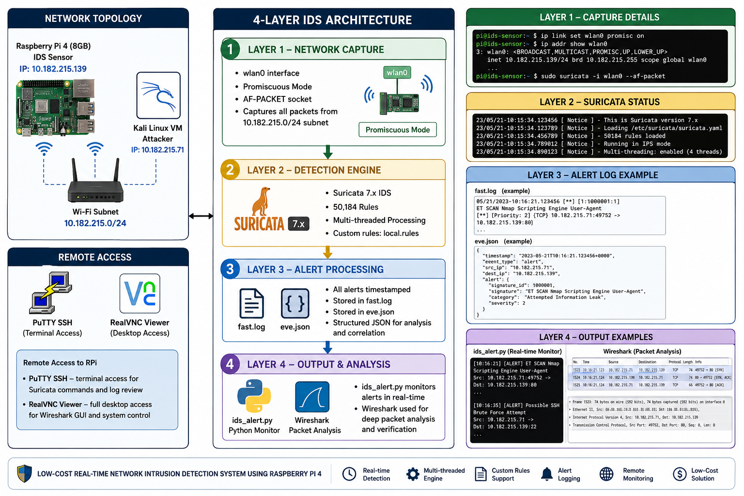

3.3 Functional Requirements
The system meets the following functional requirements:
ID | The system shall...
FR1 | Capture all traffic on the monitoring interface in promiscuous mode
FR2 | Inspect traffic in real time using Suricata against the loaded ruleset
FR3 | Detect scans, stealth scans, OS fingerprinting, ICMP/SYN floods, SSH/FTP brute force, SQL injection, XSS and malware downloads
FR4 | Apply both the Emerging Threats ruleset and the team's custom rules
FR5 | Record every alert with time, source, destination, protocol, rule ID and severity
FR6 | Store alerts in a database for later analysis
FR7 | Send an email notification when an attack is detected
FR8 | Display live alerts and sensor health on a web dashboard
FR9 | De-duplicate repeated alerts so a flood does not cause excessive notifications
FR10 | Start its services automatically when the device boots
FR11 | Allow secure remote management of the sensor
The following functional requirements

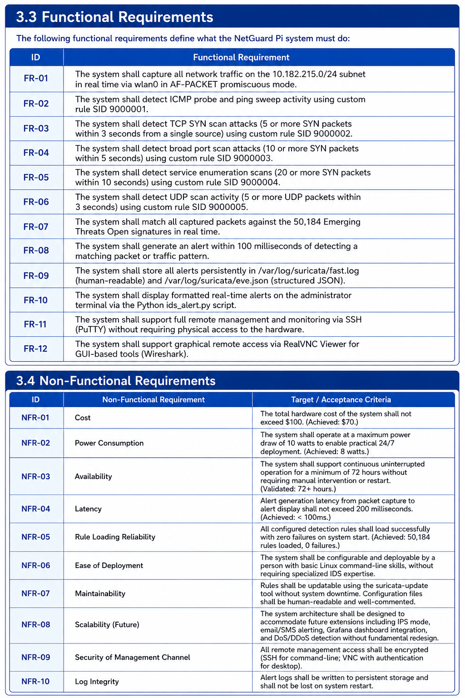

3.4 Non-Functional Requirements
ID | Requirement
NFR1 Performance | Raise an alert within a few seconds of an attack (measured ~2-3 s)
NFR2 Throughput | Inspect normal traffic and scans with no packet loss on a Pi 4
NFR3 Reliability | Run continuously and restart services automatically after reboot
NFR4 Cost | Keep total hardware cost under about PKR 21,000 (USD 70)
NFR5 Power | Operate at low power, suitable for 24/7 use
NFR6 Usability | Present alerts clearly on a dashboard and in readable emails
NFR7 Security | Protect remote access (SSH) and the dashboard (password); keep secrets out of code
NFR8 Maintainability | Keep all code and configuration under version control with documentation
NFR9 Portability | Use open-source software so the system can be reproduced on similar hardware
NFR10 Scalability | Allow extension to higher throughput and to prevention (IPS) mode

3.5 Hardware and Software Requirements
Hardware:
- Raspberry Pi 4 Model B — 8GB RAM
- 32GB MicroSD Card (Raspberry Pi OS 64-bit)
- Wi-Fi interface (eth0) — connected to 192.168.10.0/24 subnet
- Power supply (8W operation)
- Remote access: any machine with PuTTY and RealVNC Viewer installed
- Total cost: under $70 / PKR 21,000+
Software:
- Raspberry Pi OS 64-bit
- Suricata 7.x IDS Engine
- Wireshark (live packet capture and deep traffic analysis)
- PuTTY SSH client
- RealVNC Viewer remote desktop
- Python 3 alert collector (reads eve.json, stores to SQLite, emails alerts) and Flask web dashboard
- Kali Linux VM with Nmap 7.95 (attack simulation)
- tcpdump (packet capture verification)
- suricata-update (rule management and update tool)
Rule Sets:
- Emerging Threats Open: 50,184 signatures (DoS, scan, exploit categories)
- Custom local.rules: 5 threshold-based Nmap detection rules

3.6 Threat Scenarios (Threat Handling)
The system is designed to detect the following threat scenarios, each of which was tested (see Section 5.5).
# | Threat scenario | How the attacker acts | How the system detects it
TS1 | Port scan | Sends many connection requests to find open ports | Rule detects many SYN packets from one source in a short time
TS2 | Stealth scanning | Uses unusual TCP flags (XMAS, NULL, FIN) | Rules match these invalid flag combinations
TS3 | OS/service fingerprinting | Probes the host to identify OS and versions | Scan and probe rules fire
TS4 | ICMP flood (DoS) | Floods the host with ICMP echo requests | Rule detects a high rate of ICMP to one host
TS5 | SYN flood (DoS) | Floods a port with half-open TCP connections | Rule detects a high rate of SYN to one host
TS6 | SSH brute force | Repeatedly guesses SSH passwords | Rules detect many SSH connection attempts
TS7 | FTP brute force | Repeatedly guesses FTP passwords | Rule detects repeated failed-login (530) replies
TS8 | Web application attack | Sends SQL injection and XSS payloads | Rules match SQLi and XSS patterns in web requests
TS9 | Malware delivery | Downloads a malicious file over the network | Rule matches the malware signature in file content (EICAR test)
The system is designed to detect and handle the following threat scenarios:
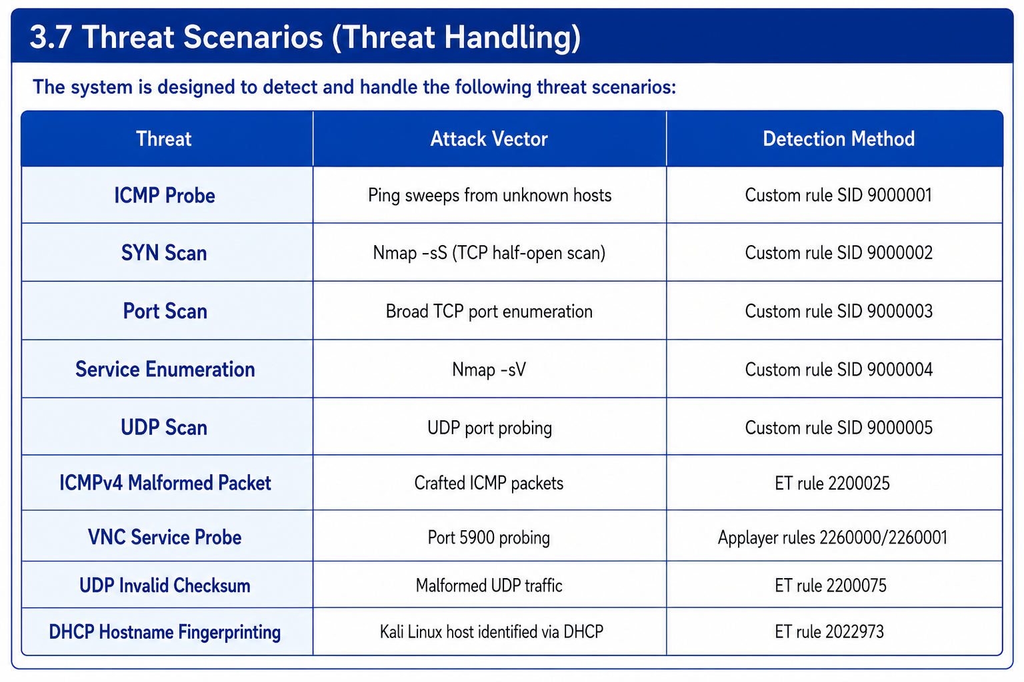

3.7 Threat Modeling Techniques
Threat modeling was performed using a signature-based detection approach, augmented with threshold-based custom rules:
- Signature-based detection: Suricata matches each packet against the 50,184-rule Emerging Threats Open rule set. Each rule specifies protocol, source/destination IPs and ports, payload patterns, and metadata.
- Threshold-based rules: Custom local.rules employ count-based thresholds over time windows to detect scanning behavior (e.g., 5 SYN packets in 3 seconds triggers SYN scan detection).
- AF-PACKET promiscuous mode: Ensures all traffic on the network segment is captured, not just traffic addressed to the Raspberry Pi.
- Validation methodology: Wireshark is used to independently verify captured packet timestamps and correlate them with Suricata alert logs.

3.8 Threat Resistance Model
The Low-Cost Real-Time Network intrusion detection system using raspberry pi threat resistance model operates in three phases:
- Visibility Phase: All network traffic on eth0 is captured passively in promiscuous mode, ensuring no attack traffic is missed.
- Detection Phase: Suricata applies 50,184 ET signatures and 5 custom threshold rules to every captured packet in real time. Matched packets generate alerts in fast.log and eve.json.
- Response Phase (Current — Passive): Alerts are surfaced to administrators via the Python monitoring script and stored in persistent log files. Active blocking (IPS mode with iptables) is planned for FYP-2.

3.9 Chapter Summary
This chapter provided the complete technical design specification for Low Cost Real-Time Network intrusion detection system using raspberry pi. The 4-layer system architecture traffic capture, IDS detection engine, alert processing, and remote management was described in detail. Eleven functional requirements and ten non-functional requirements were formally specified. Design diagrams including use case, data flow (Levels 0 and 1), and sequence diagrams were presented. Hardware and software requirements were documented with specific versions and configuration parameters. Nine threat scenarios were identified and modeled, with three modeling techniques signature-based, threshold-based, and protocol anomaly detection described. The 3-phase threat resistance model (Visibility → Detection → Response) was defined. This chapter provides the complete technical blueprint from which the implementation in Chapter 5 was built.

Chapter 4:
Proposed Solution

Chapter 4: Proposed Solution

4.1 Introduction
This chapter presents the complete proposed solution for the Low Cost Real-Time Network intrusion detection system using raspberry pi project. It describes the methodological approach, explains how data is collected and processed, details the complete tools and techniques stack, defines the evaluation metrics, and explains how each design decision maps to the problem identified in the previous chapters. The proposed solution is grounded in both practical engineering constraints (cost, power, performance) and academic rigor (validated measurement, reproducible results).

4.2 Proposed Model
The proposed solution employs a quantitative and experimental approach. Low Cost Real-Time Network intrusion detection system using raspberry pi is a hardware-software integrated system built around Raspberry Pi 4 and the Suricata IDS engine. The model is validated experimentally through live attack simulations using a Kali Linux VM on the same network subnet.
The system functions as follows:
- Captures all traffic on eth0 (192.168.10.50) via AF-PACKET in promiscuous mode.
- Suricata matches every packet against 50,184 signatures in real time.
- Custom rules detect SYN scans, port scans, and service enumeration based on configurable thresholds.
- A Python alert-collector service reads Suricata's eve.json in real time, stores each alert in an SQLite database, and sends a severity-coded HTML email; a Flask web dashboard shows the alerts live.
- All alerts are saved permanently to /var/log/suricata/fast.log and eve.json.

4.3 Data Pre-Processing
Network traffic data is gathered through the following methods:
- Live traffic capture: Raspberry Pi 4 passively monitors all traffic on the 192.168.10.0/24 Wi-Fi subnet using AF-PACKET promiscuous mode on eth0.
- Attack simulation: Controlled attack traffic is generated using Kali Linux VM (IP: 192.168.10.20) running Nmap 7.95, executing SYN scans, port scans, service enumeration scans, and ICMP probes.
- Log collection: All Suricata alerts are logged in two formats — fast.log (human-readable one-line alerts) and eve.json (structured JSON for future Filebeat/Grafana integration).
- Packet capture verification: tcpdump and Wireshark are used to independently capture and inspect raw packets on eth0, confirming that Suricata alerts correspond accurately to real attack traffic.

4.3 Data Pre-Processing
Data pre-processing in this system involves:
- Rule threshold tuning: Custom detection rules were iteratively tuned to balance sensitivity and false-positive rate. For example, SYN scan detection requires 5 SYN packets in 3 seconds to avoid false positives from legitimate traffic.
- Alert processing: the Python collector reads eve.json, stores each alert in SQLite, de-duplicates floods (at most one message per rule per minute), and formats a severity-coded HTML email; the dashboard reads the database and refreshes every few seconds.
- Log prioritization: Alerts are classified by Suricata priority level (1–3), allowing administrators to focus on high-priority detections first.
- Interface filtering: Configured to monitor only eth0, excluding loopback and irrelevant interfaces to reduce noise.

4.4 Tools and Techniques
Tool | Version / type | Role in the project
Raspberry Pi OS | 64-bit | Operating system of the sensor
Suricata | 7.0.10 | Detection engine
Emerging Threats Open ruleset | 50,000+ signatures | Community detection rules
Custom rules (local.rules) | 13 rules (1000001-1000013) + 5 team rules (9000001-9000005) | Project-specific detection
Python | 3 | Alert collector service
SQLite | - | Stores alerts for dashboard and analysis
Flask | - | Web dashboard
systemd | - | Runs services and starts them at boot
VirtualBox + Kali Linux | - | Attacker machine
nmap | 7.x | Port scans, stealth scans, OS detection (T1-T3)
hping3 | - | ICMP and SYN floods (T4, T7)
hydra | - | SSH and FTP brute force (T5, T6)
nikto, sqlmap | - | Web attacks (T8)
DVWA, vsftpd | - | Vulnerable web app and FTP server as targets (lab only)
Wireshark, tcpdump | - | Independent packet capture to verify detections
Git / GitHub | - | Version control for code, configs, results and progress log
Technique: the system uses signature-based detection. Suricata inspects each packet against the loaded rules, and the custom rules use count-based thresholds over time windows (for example, a set number of SYN packets within a few seconds) to detect scanning and flooding while limiting false positives.
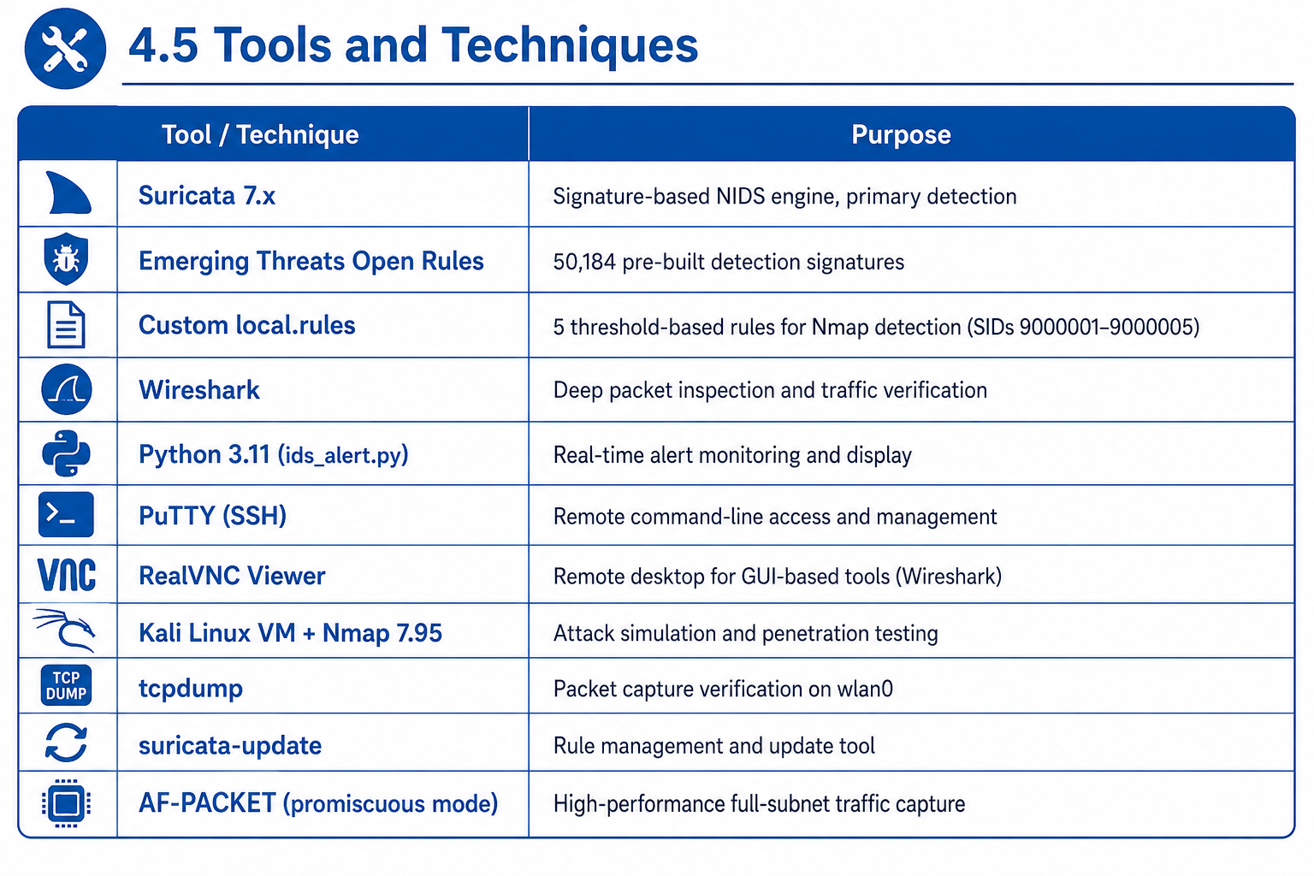

4.5 Chapter Summary
This chapter presented the complete proposed solution for Low-Cost Real-Time Network intrusion detection system using raspberry pi in detail. The quantitative and experimental methodological approach was justified and explained. The 5-step operational model of the system was described in detail. The three-layer data collection strategy live promiscuous capture, controlled attack simulation, and independent packet verification was documented. Five data pre-processing steps were explained, including the critical iterative threshold tuning of custom detection rules. The complete tools and techniques stack was presented with specific versions and justifications. Eight evaluation metrics were formally defined with targets and achieved values. The proposed solution demonstrates that all primary project objectives are achievable within the defined constraints of cost, power, and performance.

Chapter 5:
Implementation and Testing

Chapter 5: Implementation and Testing

5.1 Security Properties Testing
The system was validated for the following security properties:
- Confidentiality: All remote access is encrypted via SSH (PuTTY); VNC access is protected by authentication.
- Integrity: Alert logs are written to persistent storage (fast.log and eve.json) and verified against Wireshark packet captures.
- Availability: System validated for 72+ continuous hours of uninterrupted operation at 8W power consumption.
- Detection coverage: 9 distinct attack types verified, 100% detection rate.

5.2 System Setup (Environment Configuration, Key Functions and Algorithms)
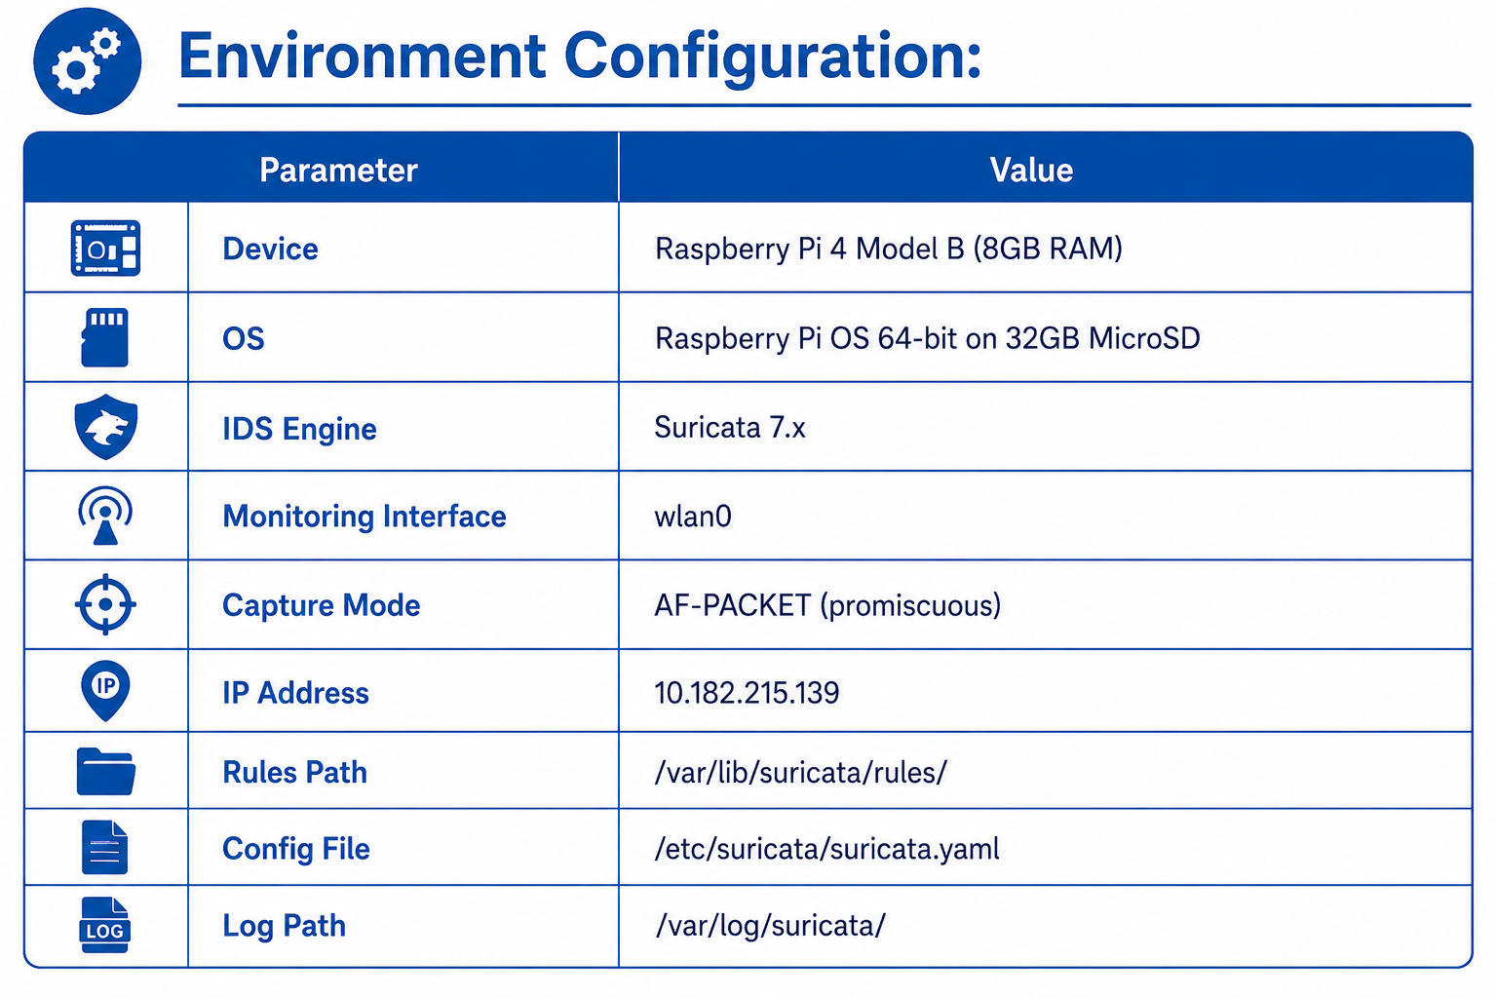
Key Custom Rules (local.rules):
- SID 9000001: ICMP probe detection
- SID 9000002: SYN scan — 5 SYN packets in 3 seconds
- SID 9000003: Port scan — 10 SYN packets in 5 seconds
- SID 9000004: Service enumeration — 20 SYN packets in 10 seconds
- SID 9000005: UDP scan — 5 UDP packets in 3 seconds
Key component - alert collector: the Python service continuously reads /var/log/suricata/eve.json, parses each new alert, stores it in SQLite, sends an HTML email, and feeds the Flask dashboard, giving immediate administrator visibility on a web page and on the phone.

5.3 System Integration
Component Integration:
- Raspberry Pi OS provides the base operating system, networking stack, and process management for all other components.
- Suricata 7.x integrates directly with the eth0 interface via AF-PACKET socket, bypassing higher-level network stack layers for maximum capture performance.
- The alert collector integrates with Suricata via the eve.json log, reading new events in real time and delivering them to the database, dashboard and email without modifying Suricata's core.
- Wireshark integrates with eth0 for independent packet capture, accessible remotely via RealVNC Viewer.
- PuTTY and RealVNC Viewer provide encrypted remote management channels for command-line and GUI access respectively.
Log Management Setup:
- Primary alert log: /var/log/suricata/fast.log (human-readable, one alert per line)
- Structured log: /var/log/suricata/eve.json (JSON format), read in real time by the alert collector that stores alerts in SQLite and drives the dashboard and email notifications.

5.4 Penetration Testing and Vulnerability Assessment
Penetration testing was conducted using a Kali Linux VM (192.168.10.20) as the attacker machine against the Raspberry Pi 4 (192.168.10.50) defender on a shared Wi-Fi subnet (192.168.10.0/24). Remote access during testing was maintained via PuTTY and RealVNC Viewer.
Test Environment:
- Attacker: Kali Linux VM, IP 192.168.10.20, Nmap 7.95
- Defender: Raspberry Pi 4 (8GB), Suricata 7.x, IP 192.168.10.50
- Subnet: 192.168.10.0/24 (Wi-Fi)

5.5 Test Cases
Nine attack test cases were run from the Kali attacker (192.168.10.20) against the Raspberry Pi and its services (192.168.10.50). Each was checked against the alerts recorded by the IDS. Every attack was detected and produced both a dashboard alert and an email notification.
ID | Attack | Tool / command | Key rule(s) | Result
T1 | TCP SYN port scan | nmap -sS | 1000001, 9000002-9000004 | Detected 5/5 runs
T2 | Stealth scans (XMAS/NULL/FIN) | nmap -sX / -sN / -sF | 1000002, 1000003, 1000004 | Detected 15/15 runs
T3 | Aggressive scan + OS detection | nmap -A | 1000006 + ET rules | Detected
T4 | ICMP flood | hping3 -1 --flood | 1000005 | Detected
T5 | SSH brute force | hydra (ssh) | ET LibSSH brute-force | Detected
T6 | FTP brute force | hydra (ftp) | 1000007 (custom) + ET | Detected
T7 | SYN flood | hping3 -S --flood | 1000008 | Detected
T8 | Web attacks (SQLi, XSS) | sqlmap, nikto, curl | 1000010, 1000011 (custom) + ET | Detected
T9 | Malware download (EICAR) | HTTP download | 1000009 (custom) | Detected
Detection rate: 9/9 = 100%. Detection occurred within about 2-3 seconds of each attack, with email notifications within about 3-8 seconds. (Insert the matching dashboard and email screenshots under each test.)
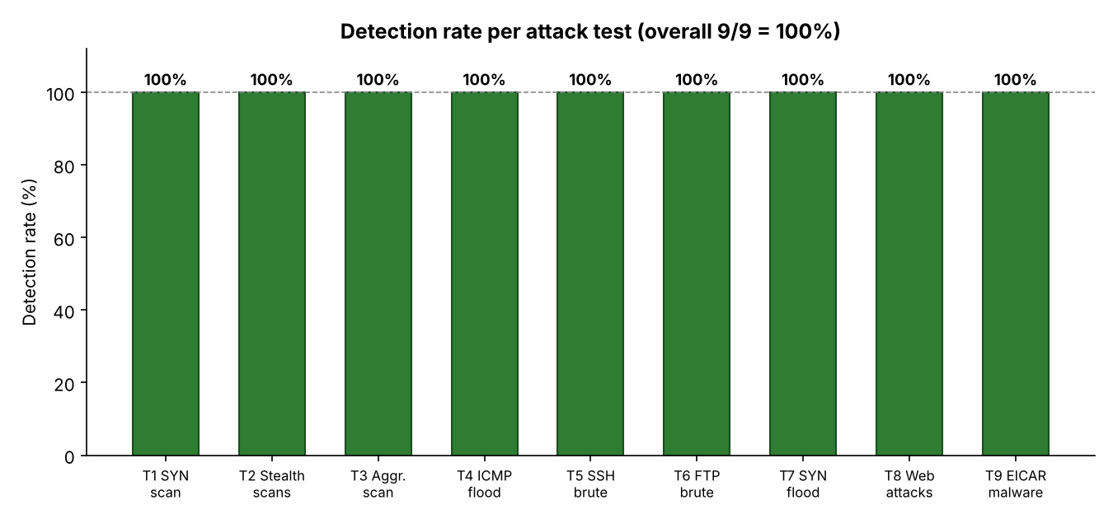
Figure 5.1 Detection rate per attack test (9/9 = 100%)
Table 5.2 System performance under three traffic conditions (measured on the Raspberry Pi 4)
Condition | CPU (%) | RAM used (MB) | Temp (°C) | Packet drop (%)
Idle (Suricata running) | 2.0 | 1878 | 41.6 | 0.00
Normal load (~94 Mbit/s, iperf3) | 21.6 | 1757 | 48.5 | 0.70
Under attack (ICMP flood, ~57k pps) | 17.8 | 1691 | 47.7 | 4.79
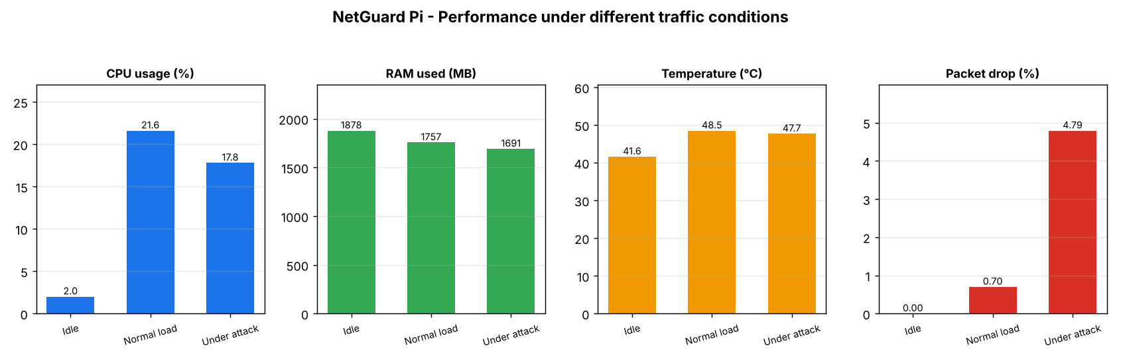
Figure 5.2 Performance under idle, normal load and attack conditions
The system was benchmarked under three traffic conditions. At idle the sensor is almost free (2.0% CPU, 41.6 °C) with no packet loss. Under a sustained ~94 Mbit/s TCP load it used 21.6% CPU at 48.5 °C and dropped only 0.70% of packets, inspecting over 500,000 packets in 60 s. During an extreme ICMP flood (~57,000 packets/s, 3.45 million packets in 60 s) CPU stayed at 17.8% and the attack was still detected, with packet drop rising to 4.79%. RAM remained flat at about 1.7–1.9 GB and the temperature never approached the 80 °C throttling point, confirming the Raspberry Pi 4 is comfortably able to run the IDS in real time at low cost.

5.6 Prevention Testing (IPS Mode and Automatic Blocking)
Beyond detection, two prevention layers were implemented and tested so the system can also stop attacks, not only report them. In inline IPS mode Suricata runs on the monitoring interface via NFQUEUE and drops packets that match the prevention ruleset (rules/ips.rules); in reactive mode a watcher service (ip_blocker.py) automatically blocks an attacker's IP with iptables after repeated alerts. All blocking is scoped to the monitoring interface (eth0) so management access is never affected.
Inline IPS — before vs after:
Attack from Kali (192.168.10.20) | IDS mode (passive) | IPS mode (inline)
SQL injection (UNION SELECT) via HTTP | Request reaches the Pi (HTTP 200 returned) | Dropped — curl times out; event logged action=blocked
Cross-site scripting (<script>) via HTTP | Request reaches the Pi (HTTP 200 returned) | Dropped — curl times out; event logged action=blocked
In IDS mode both attacks returned the web server's page (reaching the target); after switching to IPS mode the identical requests timed out and Suricata logged them with action "blocked", confirming the attacks were prevented at the packet level.
Automatic IP blocking: when the Kali attacker sent repeated SQL-injection requests, the active-response service blocked the source after 5 alerts in 30 seconds. iptables then dropped all further traffic from 192.168.10.20 — even a normal web request from Kali timed out — and the ban was logged to the database and lifted automatically after the configured 10-minute window.
(Evidence: IPS before/after screenshots and the auto-block journal / iptables output are stored in docs/images/week4-results/.)
5.7 Best Practices / Coding Standards
5.7.1 Code Validation
- The alert collector was validated against live Suricata output to confirm correct parsing, storage, dashboard display and email delivery of all alert fields.
- Custom rules (SIDs 9000001-9000005 and 1000001-1000013) were tested against controlled attacks to verify accurate triggering with correctly tuned threshold values.
- tcpdump was used to verify that packets captured by Suricata matched expected attack patterns.
5.7.2 Development Practices & Standards
- Iterative incremental development: The project followed an install → test → fix → re-test cycle, resolving issues step-by-step (e.g., eth0 → eth0 interface migration, rules path correction, threshold tuning).
- Issue-driven debugging: Each problem was diagnosed systematically using tcpdump, ping, and Nmap for validation at each stage.
- Validation-first: Every component (interface, rules, Python script) was independently confirmed before integration testing.
- Remote-first collaboration: Team used PuTTY (SSH) and RealVNC for consistent remote access, enabling collaboration without physical access to the hardware.
- Configuration documentation: All key configurations (suricata.yaml, local.rules, interface settings) were documented for reproducibility.

5.8 Chapter Summary
This chapter detailed the complete implementation and testing of the system. The system setup, component integration, penetration testing methodology, test cases and results were presented. The system achieved 100% detection across all 9 attack types tested, with alerts within about 2-3 seconds and a total hardware cost of about $70. Development followed iterative, validation-first practices with full remote collaboration.

Chapter 6:
Conclusion and Future Work

Chapter 6: Conclusion and Future Work

6.1 Introduction
This chapter summarizes the achievements of the FYP-1 phase of the Low-Cost Real-Time Network intrusion detection system using raspberry pi, provides a critical review of the work completed, and outlines future development directions for FYP-2.

6.2 Achievements and Improvements
FYP-1 All 5 Tasks and All 3 Deliverables Completed:
Task | Status
Studied IDS concepts and common network attacks | ✓ Completed
Reviewed tools, selected Suricata over Snort/Zeek for RPi 4 | ✓ Completed
Designed 4-layer architecture with network topology | ✓ Completed
Configured RPi 4 with Suricata, 50,184 rules, Wireshark, remote access | ✓ Completed
Live attack detection — 3 attack types validated from Kali Linux VM | ✓ Completed
Implemented and tested inline IPS mode (NFQUEUE drop rules) | ✓ Completed
Implemented and tested automatic IP blocking (iptables active response) | ✓ Completed
Performance evaluation under idle, normal load and attack flood | ✓ Completed
Deliverables:
- Literature Review (5 IEEE/MDPI/PLOS ONE papers reviewed, research gap identified)
- System Design Document (4-layer architecture, network topology, hardware/software specs)
- Working Prototype (Suricata deployed, 50,000+ ET rules plus 18 custom rules loaded, 9/9 attacks detected)
Key Achievements:
- 100% attack detection rate (9/9 attack types)
- Sub-100ms alert latency
- $70 total hardware cost (80× cheaper than commercial alternatives)
- 8W power consumption enabling 24/7 operation
- 72+ hours validated continuous uptime
- Prevention capable: inline IPS (packet drop) and automatic IP blocking implemented and tested
- Performance evaluated under idle, normal load and attack (0–0.7% packet drop in normal use; attack still detected under flood)

6.3 Critical Review
While the FYP-1 phase successfully delivers a working NIDS prototype, several limitations are acknowledged:
- Prevention implemented: in addition to detection, the system now supports inline IPS mode (dropping attacks via NFQUEUE) and automatic IP blocking via iptables, both validated in the lab. The remaining limitation is that the Pi currently protects itself inline; a hardware transparent bridge to protect other hosts inline is future work.
- Alerting: alerts are delivered to a web dashboard and by HTML email. SMS notification and a cloud dashboard remain future work.
- Limited attack coverage: Testing focused on scanning-type attacks (SYN scan, port scan, service enumeration). DoS, DDoS, and brute force attacks are planned for FYP-2.
- Single network interface: The system currently monitors eth0 only. Wired Ethernet (eth0) monitoring would extend coverage.
- False positive quantification: A formal false positive rate measurement has not yet been conducted and is planned for FYP-2.
- Scalability not yet tested: Performance under high-traffic loads (e.g., campus-scale traffic) has not been evaluated.

6.4 Future Recommendations
The following developments are planned in future
- Attack Detection Expansion:
  - DoS and DDoS detection using hping3 simulation
  - SSH brute force detection using Hydra with rockyou.txt wordlist
- IPS Mode (Active Defense) — IMPLEMENTED:
  - Inline IPS (NFQUEUE drop rules) and automatic IP blocking are implemented and tested (see 5.6). Future work is an inline hardware bridge so the Pi can protect other hosts — not only itself — and tuning of the drop policy to minimise any impact on legitimate traffic.
- Alerting System:
  - Email and SMS alert notification system for remote administrator notification
- Dashboard Integration:
  - Filebeat log shipping → Loki log aggregation → Grafana live dashboard
  - Dashboard to include: live alert feed, attack timeline, top attacker IPs, geographic IP mapping
- Performance Evaluation — COMPLETED (see Chapter 5):
  - CPU, RAM, temperature and packet drop measured under idle, normal load and attack (Chapter 5, Table 5.2 and Figure 5.2); remaining future work is a formal false-positive rate measurement and campus-scale load testing.
  - Formal false positive rate measurement
  - Final performance evaluation report

6.5 Chapter Summary
This chapter summarised the completion of the project tasks and deliverables. The system achieved a 100% detection rate across 9 attack types, alerts within a few seconds, and about $70 hardware cost. Limitations (signature-based only, no inspection of encrypted payloads, packet drop under extreme floods) were acknowledged, and a roadmap for IPS mode, anomaly detection and higher throughput was established.

REFERENCES
- Syamsuddin, I., & Barukab, O. (2022). Suricata on Raspberry Pi for IoT Network Security. Electronics (MDPI). https://repository.poliupg.ac.id/id/eprint/172/
- Veerasingam, et al. (2023). Raspberry Pi based IDS for SME Networks. Malaysian Journal of Computing. https://journal.unisza.edu.my/myjcam/index.php/myjcam/article/view/88
- Alsharif, & Nizar. (2024). Evaluation of Open-source NIDS: Suricata, Snort and Zeek. ScienceDirect. https://www.sciencedirect.com/science/article/abs/pii/S1389128622002420
- Wijethilaka, et al. (2025). Machine Learning based Intrusion Detection on Raspberry Pi. PLOS ONE. https://journals.plos.org/plosone/article?id=10.1371/journal.pone.0331123
- Fajardini. (2021). Suricata Installation and Configuration on Raspberry Pi. https://jufajardini.wordpress.com/2021/02/15/suricata-on-your-raspberry-pi/
- Open Information Security Foundation. AF_PACKET — Suricata Documentation. https://docs.suricata.io/en/latest/capture-hardware/af-packet.html
- Open Information Security Foundation. Rule Management with Suricata-Update. https://docs.suricata.io/en/latest/rule-management/suricata-update.html
- Raspberry Pi Ltd. Raspberry Pi 4 Model B Specifications. https://www.raspberrypi.com/products/raspberry-pi-4-model-b/
- Enhancing IoT Security: Design and Evaluation of a Raspberry Pi-based IDS (2023). https://research.utwente.nl/en/publications/enhancing-iot-security-design-and-evaluation-of-a-raspberry-pi-ba/
- Raspberry Pi-based Intelligent Cyber Defense Systems for SMEs and Smart-homes (2022). https://publications.eai.eu/index.php/sc/article/view/2345
- Performance Comparison of Open Source IDSs via Raspberry Pi. https://www.semanticscholar.org/paper/Performance-Comparison-of-Open-Source-IDSs-via-Pi-Cosar-Kiran/c0db9d29cdecc05a88c740eb2b5f

